Sr. # | Heir | Share | Share from 24 | Condition
1 | H | 1/2 | 12/24 | [CH]×
 |  | 1/4 | 6/24 | [CH]√
2 | W | 1/4 | 6/24 | [CH]×
 |  | 1/8 | 3/24 | [CH]√
3 | D | 2/3 | 16/24 | [> 2 D] [S]×
 |  | 1/2 | 12/24 | [1 D] [S]×
4 | SD | 2/3 | 16/24 | [> 2 SD] [S. D. SS]×
 |  | 1/2 | 12/24 | [1 SD] [S. D. SS]×
 |  | 1/6 | 4/24 | [1 D]√ [S. SS] ×
5 | SSD | 2/3 | 16/24 | [> 2 SSD] [S. D. SS. SD. SSS]×
 |  | 1/2 | 12/24 | [1 SSD] [S. D. SS. SD. SSS]×
 |  | 1/6 | 4/24 | [1 D or 1 SD]√ [S. SS. SSS]×
6 | F | 1/6 | 4/24 | [CH]√
7 | M | 1/6 | 4/24 | [CH]√ or [IK]√ or [H + F]√
 |  | 1/4 | 6/24 | [W + F]√ [1/6 condition]×
 |  | 1/3 | 8/24 | [1/6 condition]× [1/4 condition]×
8 | FF | 1/6 | 4/24 | [CH]√ [F]×
9 | FM | 1/6 | 4/24 | [M]× [F (Hanafi & Maliki)]× |  | If both eligible, then split 1/6. (i.e: 1/12 each)
10 | MM |  |  | [M]×
11 | RS | 2/3 | 16/24 | [>2 RS] [CH. F. FF. RB]×
 |  | 1/2 | 12/24 | [1 RS] [CH. F. FF. RB]×
12 | PS | 2/3 | 16/24 | [>2 PS] [CH. F. FF. RB. RS. PB]×
 |  | 1/2 | 12/24 | [1 PS] [CH. F. FF. RB. RS. PB]×
 |  | 1/6 | 4/24 | [1 RS]√ [CH. F. FF. RB. PB]×
13 | MT | 1/3 | 8/24 | [>2 MT] [CH. F. FF]× | Equal division regardless of gender
 |  | 1/6 | 4/24 | [1 MT] [CH. F. FF]×

Table 2: Inheritance shares (Residuary)
Sr.# | 14 | 15 | 16 | 17 | 18 | 19 | 20 | 21 | 22 | 23 | 24 | 25 | 26
Heir  →→ | S | SS | SSS | F | FF,  F3,  F4… | RB | RS | PB | PS | Res R27-  144 | Radd  (prob of return) | DI | State (bait-  ul-mal)
Add-  on | D | SD | SSD |  |  | RS |  | PS
detail | A* | A* | A*  B* |  | C* | A* | D* | A* | D* | E* | F* | G*

Guide for Table 2: Move on this table from Left to right (Sr. # 14 → 26) and assign all left over shares from table 1 to the first eligible category on Table 2. The other categories will not get any share.
A*: shares are divided in males and females of this category by 2:1. (eg: 2 parts for each son and 1 part for each daughter)
B*: From this share SD will also get a share, if she did not get it while using table 1
C*: The most proximal one in this sequence will receive the share. (eg: if FF is present then F3 will not get share, if FF is not present and F3 is present then F4 will not get share).
D*: These females will only get a share here (using table 2) if they were not eligible for a share using table 1
E*: This category of Asbah (Res) refers to additional male relatives that are related through chain of males. The closest one among them will receive the share and the rest will not. Use Table 3 to find out who is the closet in relation (Sr. # 27 → 144).
F*: Problem of excess is explained in next section.
G*: in absence of all relatives from Sr. # 1 to 24, the property can then be distributed among Dhil- Irham. The closest relative in this category will receive all the wealth.

Table 3: Finding the nearest extended Asbah (Residuary for Sr # 23):
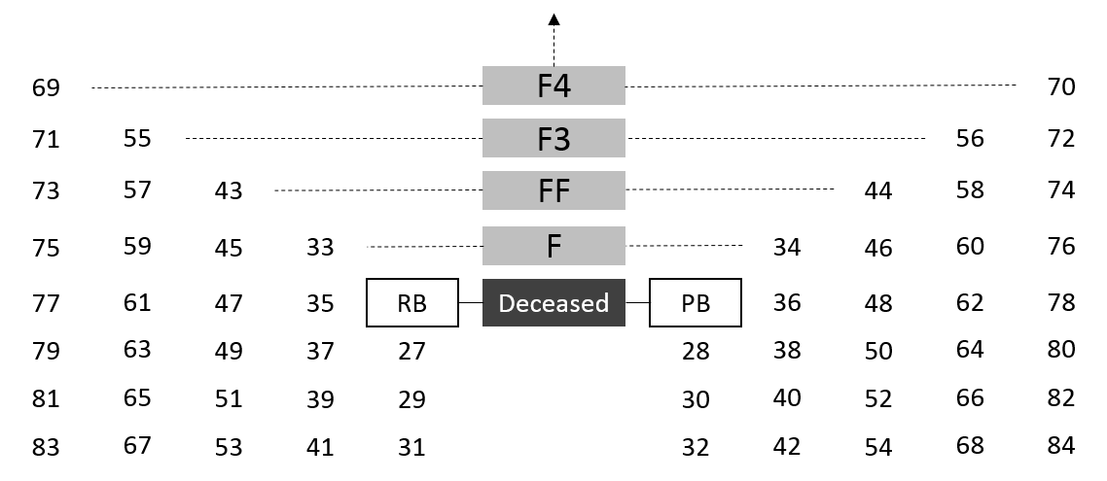

Guide for use of Table 3: The alive relative with the smallest number will be considered eligible for nearest Asbah (residuary) and will inherit the residual wealth. Other people will not get any share. The chain can continue beyond F4 in the same sequence.

